French SREN Law 2024 Compliance for Log360
Tagline: Navigate cloud and digital space security obligations under France's SREN Law 2024 with Log360.

Overview
The French SREN Law 2024 (Securing and Regulating the Digital Space) Compliance extension for Log360 enables French cloud service providers, digital platform operators, and regulated businesses to meet the security monitoring, data residency, and incident response requirements introduced by the SREN Law.
Log360 provides a cloud-native SIEM that collects and analyzes logs from cloud workloads, access systems, and digital service infrastructure, supporting continuous monitoring and compliance reporting. Security and DPO teams can detect threats, maintain audit trails, and generate evidence for ANSSI and CNIL oversight.

Key Features
- Generate predefined audit reports covering SREN Law security obligations for cloud and digital service providers, including access monitoring and incident logging.
- Monitor cloud application usage, user activity, and data movement to detect shadow IT, unauthorized data transfers, and policy violations.
- Leverage CASB capabilities in Log360 to gain full visibility and control over cloud environments as required under SREN digital governance obligations.
- Export compliance evidence in PDF and CSV formats for ANSSI and CNIL regulatory submissions and internal governance records.
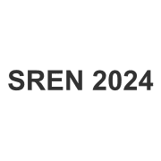
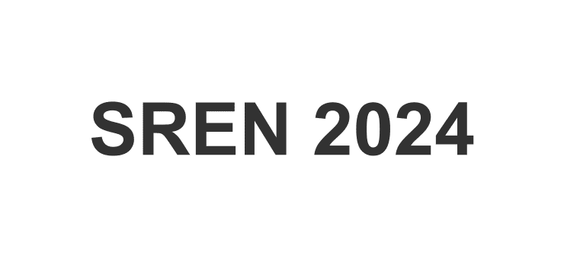

Screenshots
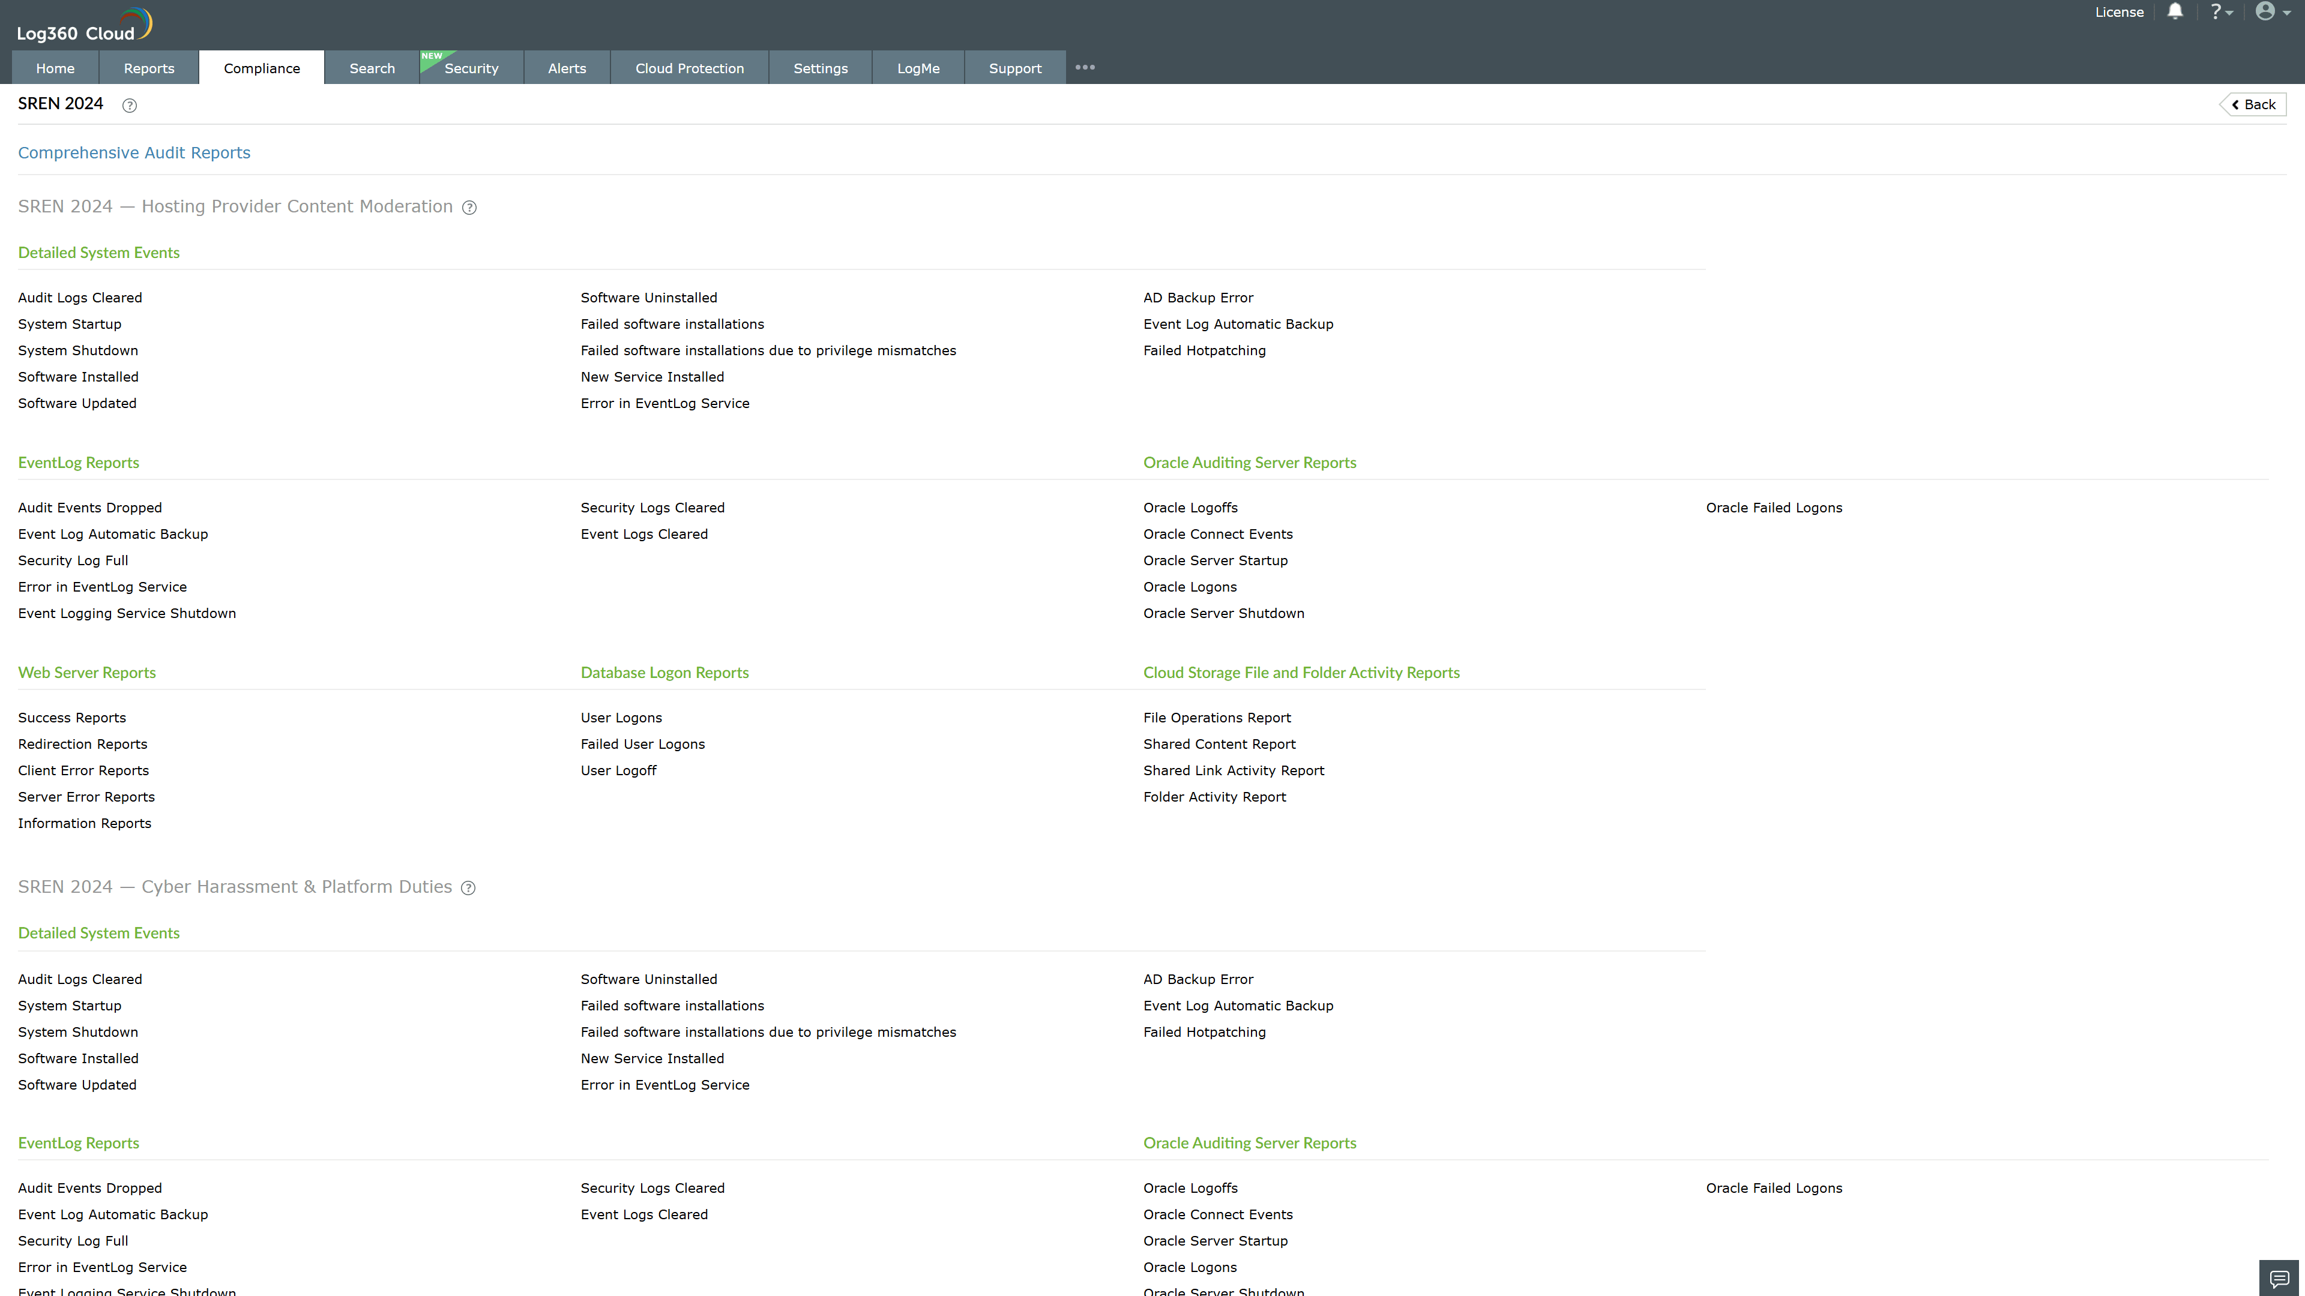
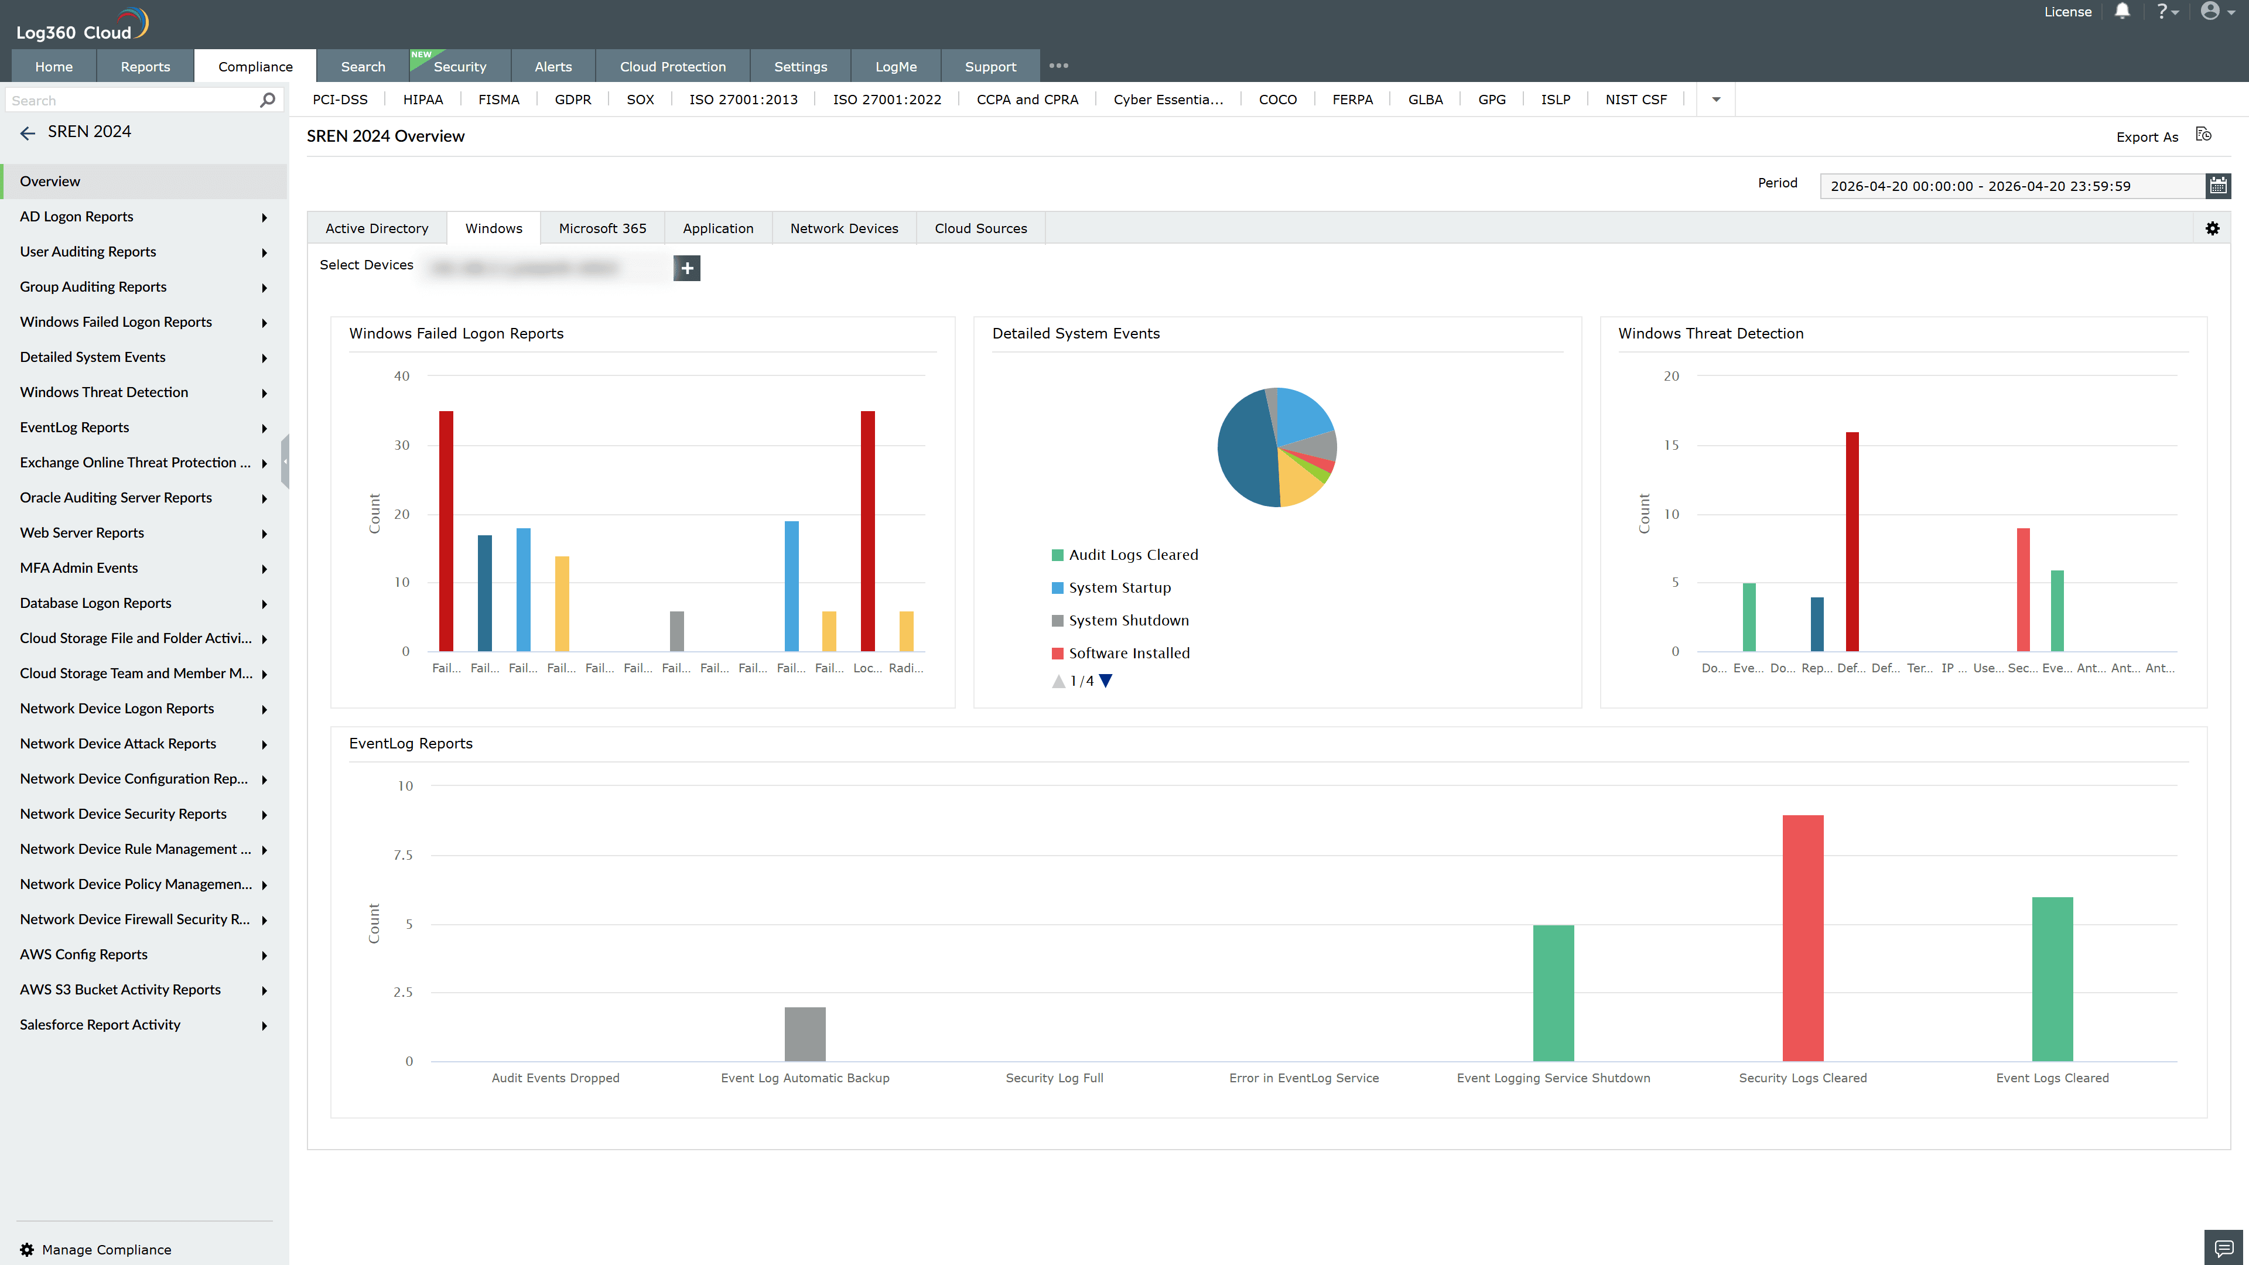
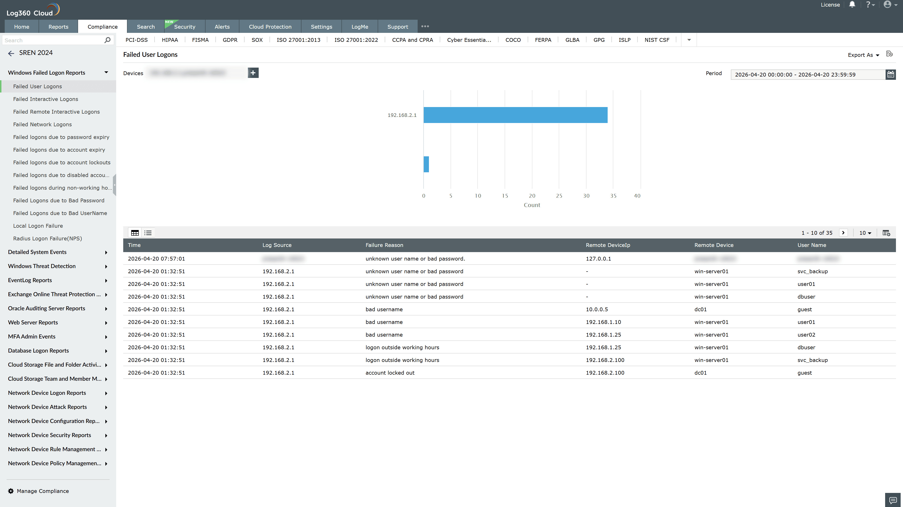
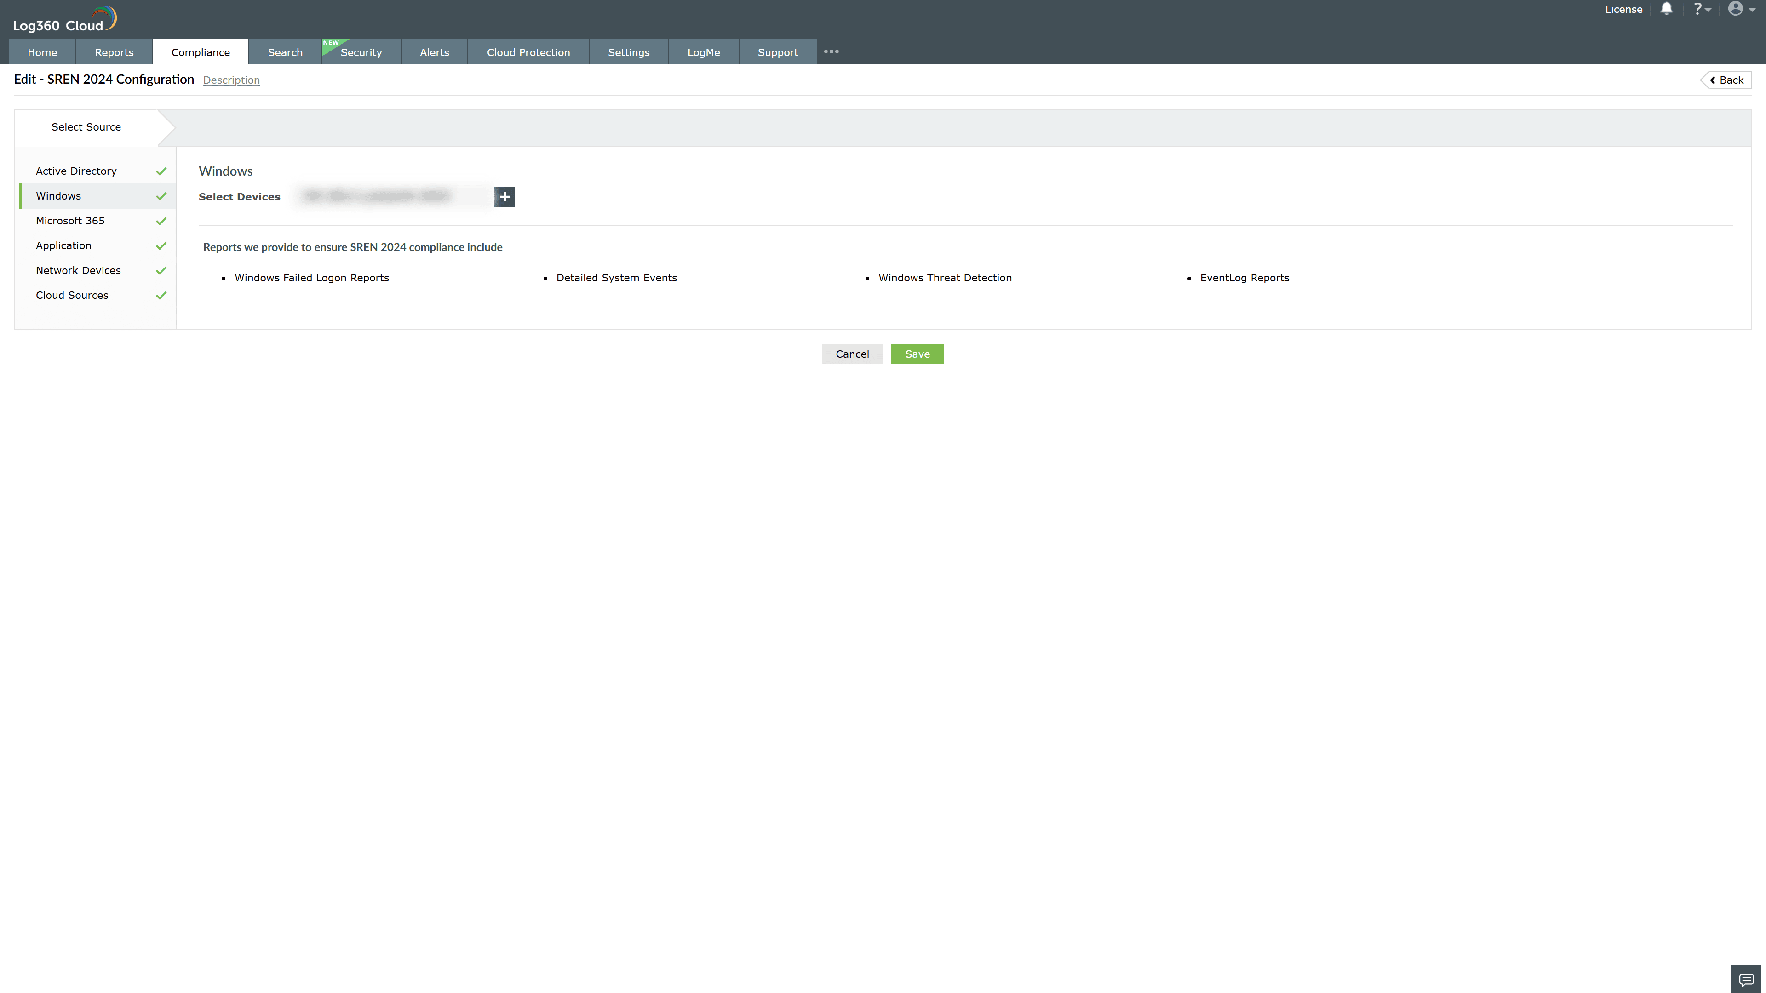

Valid Submission : Yes
Supported Editions : Free, Basic, Standard, Professional, MSSP
Help Document : https://www.manageengine.com/log-management/help/integrations/compliance-extensions.html
Help Video : Not provided
Tags : Log360, Compliance, Privacy monitoring, Data privacy, Regulatory compliance
Supported DCs : US, IN, JP, CA, AU, UK and EU
Privacy Policy:
Terms of Service:
Release Notes:
Predefined reports for the French SREN Law 2024 Compliance

